Programme: Erasmus +, K2, Strategic Partnership; ID KA2-VET-20/17
Project Title: Networking for Entrepreneurship
Project Acronym: NET-ENT
Grant Agreement No.: 2017-1-SI01-KA202-035580 Project Website: http://netent.scng.si/
Partner: Šolski center Nova Gorica

DISSEMINATION AND EXPLOATATION REPORT

Dissemination /Exploatation | Date | Place | Target groups | Number of Participants | Evidences
Description of the project on the partner's website | 11.11.2017 | Webpage http://www.scng.si/ | the general public, teachers, students |  | Link: http://mic.scng.si/net-ent-networking-entrepreneurship/
ECVET international conference; ECVET Peer Learning Seminar in Slovakia  »Using ECVET Principles in Work Based Leraning with Special Focus on  Involvment of all relevant Stakeholders«  Creating new curriculum NET-ENT Networking for Entrepreneurship | 9. + 10. 11. 2017 | Bratislava | EU decisio makers and ECVET representatives | 34 | Agenda – event program  Power point presentation  Resume  Photos
News – 1. meeting | 16.11.2017 | ŠCNG website | the general public, teachers, students |  | 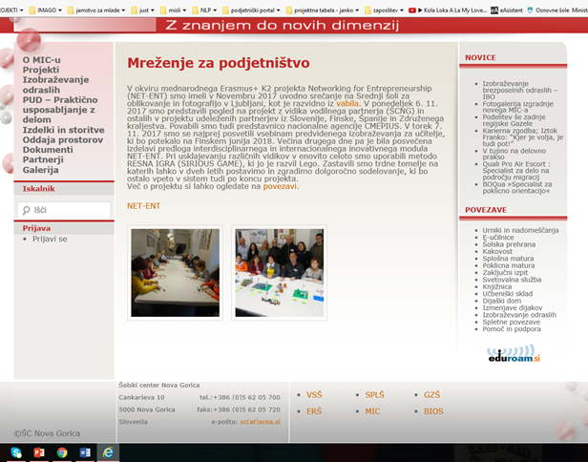
News – 2. meeting | 23. 3. 2019 | ŠCNG website | the general public, teachers, students |  | Link: http://mic.scng.si/drugo-srecanje-partnerjev-net-ent/  http://mic.scng.si/drugo-srecanje-partnerjev-net-ent/
Workshop | 21.1.2020 | School Centre Nova Gorica | Students, teachers | 25 | 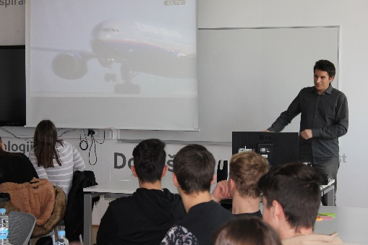  Participation list
News about the Workshoop | 21.1.2018 | Webpage http://www.scng.si/ |  | News about the Workshoop | Link: http://mic.scng.si/net-ent-od-ideje-produkta-marketing-prakticni-primeri-nasveti/
Workshop | 29.1.2018 | School Centre Nova Gorica | Students, teachers | 27 | Prticipation list 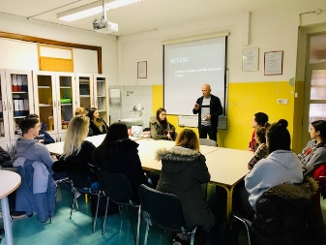
News about the Workshoop | 29.1.2018 | Webpage http://www.scng.si/ | the general public, teachers, students |  | Link: http://mic.scng.si/net-ent-od-ideje-produkta-oblikovanje-vizualne-komunikacije/
Article - learning firms fair | 12.4.2018 | Celje, Slovenia | Students, teachers | Fair participants – more than 500 | Link: http://cups.splet.arnes.si/files/delightful-downloads/2019/04/CUPS-2019-Tanja-U%C5%A1aj-Hvali%C4%8D.pdf  Photos - 10  Article - 1
News – Training of Trainers | 15.6.2018 | Webpage http://www.scng.si/ | the general public, teachers, students | 32 | Link: http://netent.scng.si/2018/09/20/izobrazevanje-izobrazevalcev/  Photos – 11
News – Training of Trainers | 16.6.2018 | Webpage http://sets.scng.si/projekt-net-ent/ | the general public, teachers, students |  | Link: http://sets.scng.si/projekt-net-ent/
Article | 2.4.2019 | Webpage http://www.scng.si/ | the general public, teachers, students |  | Link: http://netent.scng.si/files/2018/05/Erasmus_NET-ENT.pdf
Info to all principals on ŠCNG | 10.5.2019 | Via e-mail | policy makers | 7 | e-mail text
Presentation of the project in Germany – K1 | 12.11.2019 | Wippefur, Germany | Simmilar schools, potential users | 6 (Germany, Estonia, Spain) | Attendance list (presence recording sheet)  Photos  Power Point presentation  Brochure  Outcome: we are now applying together the project KA 2 Erasmus+, where the coaching as innovation in teaching and learning will be introduced and used.
Presentation of the project | 10 th of December 2019 | United Kingdom – Birmingham | Simmilar schools, potential users | 21 participants from 4 schools and 3 Chambers of Commerce (Bulgaria, United Kingdom, Turkey, The Republic of North Macedonia). | Attendance list (presence recording sheet)  Photos  Power Point presentation  Brochure  Outcome: They were impressed with the module developed and the pilot implementation movies. They want to use the results in their organisations.
Article | 22. 2. 2020 | Newspaper: Primorske Novice | Public | Wider public | Article
Nacionalne novice na spletni strani projekta | Promptly |  | Teachers |  | http://netent.scng.si/national-news/

